**ABSTRACT**

The aim of this study was to know how Digital Marketing works for startups and how it is the future of advertising. This study is based on tried and tested data which has been previously analysed and filtered. The data collected, although is based on the absolute need of the business, is customised. Based on this study, we can say that the future of advertising lies in inobtrusive technology that follows the latest privacy directives and provides a high-quality user experience. This study also shows how each startup needs to apply all the Digital Marketing resources using their own thought processes and how creativity is needed to attract people. It enlists various directions in which Digital Marketing can be applied and numerous techniques which when modified according to one's experience can result in magnificent outcomes.

**CHAPTER 1**

**INTRODUCTION**

Today’s era of the Internet has opened a gate of vast variety of opportunities for businesses. Using social networks, one can not only share a private picture of their birthday, but also earn customers for their business and reach them conveniently. The speed and ease with which the digital media transmits information and helps boost a business is amazing.

People are consuming digital content on a daily basis. Very soon, traditional marketing platforms will disappear, and the digital market will completely take over. There are a number of advantages in Digital Marketing. Unlike traditional marketing, digital marketing is more affordable.You can reach a larger audience in a shorter time period. Technological advances have resulted in considerable attrition of the customer-base of traditional marketing agencies and departments. People have moved on to tablets, phones, and computers, which are the areas where digital marketers have gained the most ground.

**1.1. MEANING**

Digital marketing is the use of digital technologies and platforms to promote products and services, as well as to connect with potential customers. It is an incredibly versatile and powerful tool that can be used in various ways to reach people worldwide. Digital marketing utilises multiple digital technologies to deliver promotional messages, such as mobile phones, computers, andMedium of communication is mostly through social media websites, chat, and Email. other digital media and platforms. It can be used for B2B (Business to Business) and B2C (Business to Consumer) marketing, depending on the goal and objectives of the campaign. Digital marketing offers unique advantages such as greater reach, improved targeting, personalised messaging, and better ROI (Return on Investment). It also allows businesses to stay up-to-date with marketing trends and technologies. With the right strategies and tactics, companies can leverage digital marketing to increase their visibility and reach a larger audience.

Therefore, any digital channels by a business or company to market or promote products and services to consumers are referred to as digital marketing and different websites, mobile devices, social media, search engines, and similar channels are used in digital marketing.

**1.2. EVOLUTION**

**The Timeline**

**The 90s**

Archie, the first search engine, debuted in the early 1990s, heralding the birth of search. SEO, or Search Engine Optimization, quickly followed. The first clickable web-ad banners were introduced in 1994. The first identifiable social media site was launched in 1997, with 3.5 million users. In the 1990s, a slew of websites still in use

was found, including Google and Yahoo's web search, both of which debuted in 1998.

**The Millennial Generation**

A massive economic bubble grew in the new millennium. However, the bubble's peak and burst between 2000 and 2002 harmed many businesses. Many new sites were launched in the 2000s as the economy recovered from the boom, including the beginnings of LinkedIn in 2002, Myspace and WordPress in 2003, and Facebook in 2004. In the early 2000s, mobile text messaging marketing became increasingly popular.

**The Mobile Era**

The latter half of the decade saw increased marketing and sales, with Amazon's e-commerce sales surpassing $10 billion. Over the next few years, mobile app culture expanded with the introduction of Whatsapp, Instagram, and Snapchat to the digital world.

**The Present**

Today, 65% of an individual's digital media time is spent on a mobile device. The digital advertising industry is now valued at around $200 billion, with Google Ad Words accounting for 96% of the company's revenue. With an estimated 3.1 billion online users, social networking has led the digital marketing revolution. The rise of bloggers and Instagram has resulted in a $1 billion industry for influencers, which are anticipated to grow. Digital marketing is expected to grow in the coming years, with many new developments and changes in this exciting industry.

**Here are some differences between digital marketing and traditional marketing-:**

**Traditional Marketing -**

* Communication is unidirectional, i.e, a business communicates about its products or services with a group of people.
* Medium of communication is generally phone calls, letters, and Emails.
* Campaigning takes more time for designing, preparing, and launching.
* It is carried out for a specific audience throughout from generating campaign ideas up to selling a product or a service.
* It is a conventional way of marketing, best for reaching local audiences.
* It is difficult to measure the effectiveness of a campaign.

**Digital Marketing -**

* Communication is bidirectional, the customer also can ask queries or make suggestions about the business products and services.
* Medium of communication is mostly through social media websites, chat, and Email.
* There is always a fast way to develop an online campaign and carry out changes along its development. With digital tools, campaigning is easier.
* The content is available for the general public, it is then made to reach the specific audience by employing search engine techniques.
* It is best for reaching global audiences.
* It is easier to measure the effectiveness of a campaign through analytics.

**1.3. FEATURES**

The best digital marketers have a clear picture of how each digital marketing campaign supports their overarching goals. And depending on the goals of their marketing strategy, marketers can support larger campaigns through free and paid channels at their disposal. A content marketer, for example, can create a series of blog posts that serve to generate leads from a new eBook the business recently created. The company's social media marketer might then help promote these blog posts through paid and organic posts on the business's social media accounts. Perhaps the email marketer creates an email campaign to send those who download the eBook more information about the company. Following are some of most common digital marketing tactics and the channels involved -

1. **Search Engine Optimization (SEO) :** This is the process of optimising a website to rank higher in search engine results pages, thereby increasing the amount of organic traffic your website receives.The channels that benefit from SEO include Websites, Blogs, and Infographics.
2. **Social Media Marketing :** This practice promotes your brand and your content on social media channels to increase brand awareness, drive traffic, and generate leads for your business.The channels you can use in social media marketing include Facebook, Twitter, LinkedIn, Instagram, Snapchat, Pinterest, and Google+.
3. **Content Marketing :** It denotes the creation and promotion of content assets for the purpose of generating brand awareness, traffic growth, lead generation, and customers.The channels that can play a part in your content marketing strategy include Blog posts, EBooks and whitepapers, Infographics, Online brochures and look books.
4. **Affiliate Marketing :** This is a type of performance-based advertising where you receive commission for promoting someone else's products and services on your website. Affiliate marketing channels include hosting video ads through the YouTube Partner Program and Posting affiliate links from your social media accounts.
5. **Native Advertising :** Native advertising refers to advertisements that are primarily content-led and featured on a platform alongside other, non-paid content. BuzzFeed-sponsored posts are a good example, but many people also consider social media advertising to be native – Facebook advertising and Instagram advertising.
6. **Marketing Automation :** Marketing automation refers to the software that serves to automate your basic marketing operations. Many marketing departments can automate repetitive tasks they would otherwise do manually, such as Email newsletters, Social media post scheduling, Contact list updating, Lead-nurturing workflows, Campaign tracking and reporting.
7. **Pay-Per-Click (PPC) :** PPC is a method of driving traffic to your website by paying a publisher every time your ad is clicked. One of the most common types of PPC is Google Ad Words, which allows you to pay for top slots on Google's search engine results pages at a price "per click" of the links you place. Other channels where you can use PPC mainly include Paid ads on Facebook, Promoted Tweets on Twitter, Sponsored Messages on LinkedIn.
8. **Email Marketing :** Companies use email marketing as a way of communicating with their audiences. Email is often used to promote content, discounts and events, as well as to direct people toward the business's website. The types of emails you might send in an email marketing campaign include Blog subscription newsletters, Follow-up emails to website visitors who downloaded something, Customer welcome emails, Holiday promotions to loyalty program members, Tips or similar series emails for customer nurturing.
9. **Inbound Marketing :** Inbound marketing refers to the "full-funnel" approach to attracting, engaging, and delighting customers using online content. You can use every digital marketing tactic listed above throughout an inbound marketing strategy.

**1.4. ADVANTAGES**

Regardless of what your company sells, digital marketing still involves building out buyer’s personas to identify your audience’s needs and creating valuable online content.

1. **B2B Digital Marketing :** If a company is business-to-business (B2B), digital marketing efforts are likely to be centred on online lead generation, with end goal being for someone to speak to sales person.The role of your marketing strategy is to attract and convert highest quality leads for sales people via your website and supporting digital channels. Beyond websites, you'll probably choose to focus efforts on business-focused channels like LinkedIn where your demographic is spending their time online.
2. **B2C Digital Marketing :** If your company is business-to-consumer (B2C), depending on the price point of products, the goal of digital marketing efforts is to attract people to your website and have them become customers without ever needing to speak to a salesperson.For that reason, you're probably less likely to focus on leads in their traditional sense, and more likely to focus on building an accelerated buyer's journey, from the moment someone lands on your website, to the moment that they make a purchase. This will often mean your product features in your content higher up in the marketing funnel than it might for a B2B business, and you might need to use stronger call-to-action(CTAs). For B2C companies, channels like Instagram and Pinterest are more valuable than business-focused platforms like LinkedIn.
3. **Website Traffic :** You can see the exact number of people who have viewed your website's homepage in real time by using digital analytics software, available in marketing platforms like HubSpot. Also how many pages they visited, what device they were using, and where they came from, amongst other digital analytics data. This intelligence helps you to prioritise which marketing channels to spend more or less time on, based on the number of people those channels are driving to your website. For example, if only 10% of your traffic is coming from organic search, you know that you probably need to spend some time on SEO to increase that percentage.
4. **Content Performance and Lead Generation :** Imagine you've created a product brochure and posted it through people's letterboxes - that brochure is a form of content, albeit offline. The problem is no idea how many people opened your brochure or how many people threw it straight into trash.
5. **Attribution Modelling :** An effective digital marketing strategy combined with right tools and technologies allows to trace all sales back to the customer's first digital touch point with your business is called attribution modelling. It allows identifying trends in the way people research and buy your product, helping you to make more informed decisions about what parts of your marketing strategy deserve more attention, and what parts of your sales cycle need refining. Connecting the dots between marketing and sales is hugely important - according to Aberdeen Group, companies with strong sales and marketing alignment achieve a 20% annual growth rate, compared to a 4% decline in revenue for companies with poor alignment. If you can improve your customers' journey through the buying cycle by using digital technologies,then it's likely to reflect positively on your business's bottom line.
6. **Collaborative Environment :** A collaborative environment can be set up between the organisation, technology service provider, and digital agencies to optimise effort, resource sharing, reusability and communications. Organisations are inviting their customers to help them better understand how to service them. Much of this is acquired via company websites where the organisation invites people to share ideas that are then evaluated by other users of the site. Using this method of acquiring data and developing new products can foster the organisation's relationship with their customer as well as spawn ideas that would otherwise be overlooked.
7. **Data-driven advertising :** Users generate a lot of data in every step they take on the path of customer journey and brands can now use that data to activate their known audience with data-driven programmatic media.
8. **Remarketing :** Remarketing plays a major role in digital marketing. This tactic allows marketers to publish targeted ads in front of an interest category or defined audiences, generally called searchers in web speak,they have either searched for particular products or services or visited a website for some purpose.

1. **Game advertising :** Game ads are advertisements that exist within computer or video games. One of the most common examples of in-game advertising is billboards appearing in sports games. In-game ads also might appear as brand-name products like guns, cars, or clothing that exist as gaming status symbols.
2. **Ease of access :** A key objective is engaging digital marketing customers and allowing them to interact with brands through servicing and delivery of digital media. Users with access to the Internet can use many digital mediums,such as facebook, YouTube, forums and Email etc. Through digital communications it creates a multi-communication channel where information can be quickly shared around the world by anyone without any regard to who they are.

**1.5. DISADVANTAGES**

With advantages come a few disadvantages too -

**1. High competition**

The digital marketing campaign should be well thought out, stand out, grab attention and impact the target audience since the competition has grown many folds recently. Any monotonous approach or repeated method will drive the brand out of the competition in no time. Digital marketing campaigns have become very competitive. Thus, brands must be relevant to the customers’ needs and be quick in responding.

**2. Dependability on Technology**

Digital marketing is purely based on technology, and the internet is prone to errors. There are times when the links may not work, landing pages may not load, and page buttons just don’t simply do their job. This leads prospective customers to switch to other brands. Therefore, to avoid this, a test of the website is necessary. Also, proofreading the content and ensuring the campaigns will work on their targeted niche becomes important.

**3. Time Consuming**

One of the biggest disadvantages of digital marketing campaigns is their time-consuming nature. Unorganised tactics and strategies may consume a lot of time, and it becomes difficult to devote the desired time to the campaign. This will eventually lead to negative results. Therefore, it has been suggested to focus on a strategy that the company needs the most and plan and curate the content accordingly. Digital marketing tools like HubSpot, Ahrefs and social media posting, and scheduling tools like Hootsuite and Tweetdeck should be used to overcome the potential barriers.

**4. Security and Privacy Issues**

Security is the primary requirement for any brand. Hence website protection is something to be executed seriously as a digital marketer. Securing and safeguarding the network connections by using firewalls and encryption tools like VPN is always suggested. The basic approach of having a good antivirus is most desirable. The legal considerations in obtaining customer data for digital marketing strategies must be done with all required formalities. Protecting the customer data should be the top priority as it may be compromised during data breaches.

**CHAPTER 2**

**REVIEW OF LITERATURE**

1. **Karan Sharma (Aug, 2018) -**

Running a startup and surviving the cut-throat competition is an achievement. There are a myriad of things that need attention like finances, managing the product, building relationships with clients, and more. Everything requires exhaustive research and an eye for detail. Luckily, digital marketing can help with some of these challenges.

1. **Dave Chaffey (2020) -**

Where do you start if you want to develop a digital marketing strategy? It's still a common challenge since many businesses know how vital digital and mobile channels are today for acquiring and retaining customers. Yet they don't have an integrated plan to support digital transformation and business growth, and engage their audiences effectively online.

1. **Aden Andrus (April,2020) -**

Like any other type of marketing, digital marketing is a way to connect with and influence your potential customers. The difference is that you do so online through a combination of digital marketing channels that include video content, social media posts, content marketing, web and social media advertisements, and search engine marketing. Companies reach goals through the above means instead of using traditional marketing strategies like billboards, television ads, and promotional mail sent to consumer residences.

1. **Dom Nicasto (Dec, 2021) -**

Marketers face the prospects of complying with existing consumer data privacy laws, grappling with new ones expected in 2022 and managing customer data all while dealing with forces like third-party cookie tracking fading away. About 61% of high-growth companies are shifting to a first-party data strategy, while only 40% of negative growth companies say the same.

1. **Coursera.org (July, 2022) -**

Digital marketing, or online marketing, is a form of advertising that uses the internet and digital technologies to connect with customers. Digital marketing seeks to accomplish the same thing as traditional marketing except by leveraging computers, smartphones, and other digital devices rather than traditional media, such as print, radio, or television.

1. **Vaishnavi M R (January, 2023) -**

The term Marketing is not just about promoting and advertising. It is a complex concept where you send across the right message to the right person via the right medium. Now, talking about Digital Marketing, it is promoting your business through digital channels like the internet, website, email and many more.

1. **Avantika Monnappa (Feb, 2023) -**

In a world where over 170 million people use social media on a regular basis, every working professional is expected to be familiar with at least the core tenets of Digital Marketing. In simple terms, Digital Marketing is the promotion of products over the internet or any form of electronic media.

1. **Lizzie Davey (Feb, 2023) -**

Ecommerce success is driven by many factors beyond the first step of launching an online store. To get your business out there, you need to market your brand and website to drive traffic, which should ultimately lead to more sales. This is where digital marketing comes into play. Effective digital marketing will create a buzz around your company and products, earn trust from your audience, and push people to your online store to eventually make a purchase—and return in the future for more.

1. **Aashish Pahwa (Feb, 2023) -**

Digital marketing is a growth machine and anyone who gets his hand on it is a winner in the 21st century. But it doesn’t result in profits overnight. It requires marketers to be alert and watch out for changes in customers’ preferences and adapt to meet those needs and preferences accordingly.

1. **Disha (March, 2023) -**

Digital Marketing encompasses all marketing efforts that promote your product or brand using electronic devices or the internet. It leverages online marketing tactics like search marketing, email marketing, social media marketing, and mobile marketing to connect with current and prospective customers.

1. **Adam Barone (March, 2023) -**

The term digital marketing refers to the use of digital channels to market products and services in order to reach consumers. This type of marketing involves the use of websites, mobile devices, social media, search engines, and other similar channels. Digital marketing became popular with the advent of the internet in the 1990s. Digital marketing involves some of the same principles as traditional marketing and is often considered a new way for companies to approach consumers and understand their behaviour. Companies often combine traditional and digital marketing techniques in their strategies. But it comes with its own set of challenges, including implicit bias.

1. **Ron Sela (2023) -**

You know that you need to target your audience; you’re trying, but somehow it feels like you’re just not quite hitting the mark. In that case, you must start doing a target audience analysis. Your content and products can’t appeal to your target market if you don’t understand them.

1. **Neil Patel -**

Digital marketing is the act of promoting products and services through digital channels, such as social media, SEO, email, and mobile apps. Any form of marketing that involves electronic devices is considered digital marketing. It can be done online and offline; in fact, both kinds are important for a well-rounded digital marketing strategy.

1. **Engaiodigital.com -**

Digital marketing includes online channels such as search engines, social media, email, applications, websites, and any new digital channels that might arise with the possibility of advertisement. It also includes offline channels that include digital media as well. The growth of digital media and digital platforms has made digital marketing the most potent form of marketing. Even traditional channels are changing to fit more digital media into them, and that emphasises its importance in a modern-day marketing strategy.

1. **Salesforce.com -**

Digital marketing is any marketing action that occurs on digital platforms, regardless of whether the device is connected to the internet. Under the umbrella of digital marketing is online marketing, which includes email marketing, paid ads on social media platforms, and search engine optimization (SEO).

**Chapter 3**

**3.1. OBJECTIVES**

* To know about digital marketing strategies and its performance as a startup
* If digital marketing is the future of advertising

**3.2. METHODOLOGY**

**Secondary Data :** Secondary data is collected from journals, books and the internet to develop the theory.

**3.3. SCOPE**

The need of this study is to understand how Digital Marketing works for startups and what tactics and strategies are used in it to do so.

The scope for this study is the future for startups and how startups can grow as big time businesses in the future.

**3.4. LIMITATIONS OF THE STUDY**

The limitations to this study are as follows

* This study is based on secondary data, thus it is limited only to bookish and internet information.
* The study covers almost all aspects of digital marketing as a startup, henceforth having limited scope compared to the scope of the entire digital marketing market.
* The startup taken into consideration in this project, does not have much about it on the internet or articles, so it is very brief about how they work and perform.

**Chapter 4**

**COMPANY PROFILE**

PictureThis is a startup company started in 2022 with two founding directors - Mohammed Ahmer and Nasir Ali, and a team of four people - Nasir Ali, Mohammed Ibraheem Ali, Mohammed Talha and Naveen Kumar, who manage all the tasks like strategising, editing, filming, shooting and content creating, they initially started their work with three major clients - TheMVP, Emerson and INNO3D.

This company provides most of the digital marketing facilities needed on various social media platforms.

**4.1. What Do They Do?**

**Post Production**

Whether it’s a Youtube video, TikTok reel, or a Cinematic ad. It's Video Editing – done on time, the way you want it.

**Branding**

Want your brand to look quirky? or sophisticated? The first impression is always a visual one – so let’s make sure you get it right.

**Social Media**

Don’t just engage followers. Convert them into loyal customers. Our social media content makes an impact where it matters.

**4.2. Their Portfolio**

**Cinematic Video**



**UI/UX Website Design**

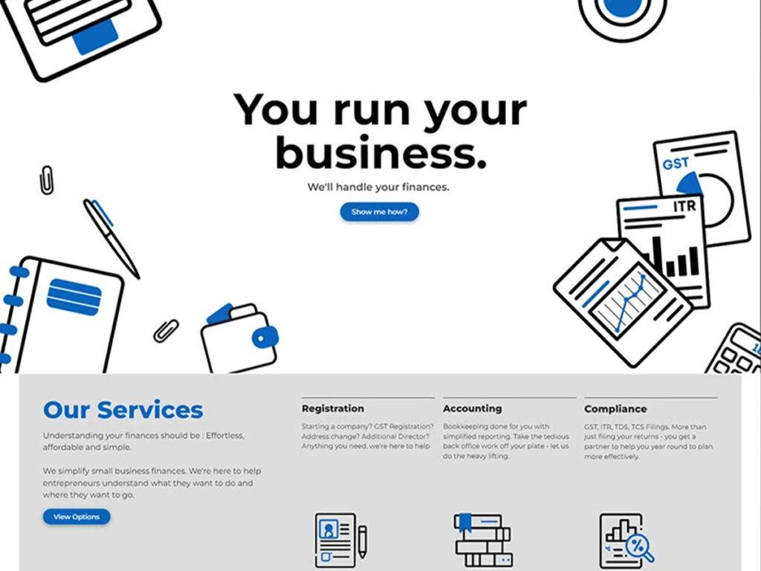

**Branding – Case Study**



**Product Photography**



**Social Media Management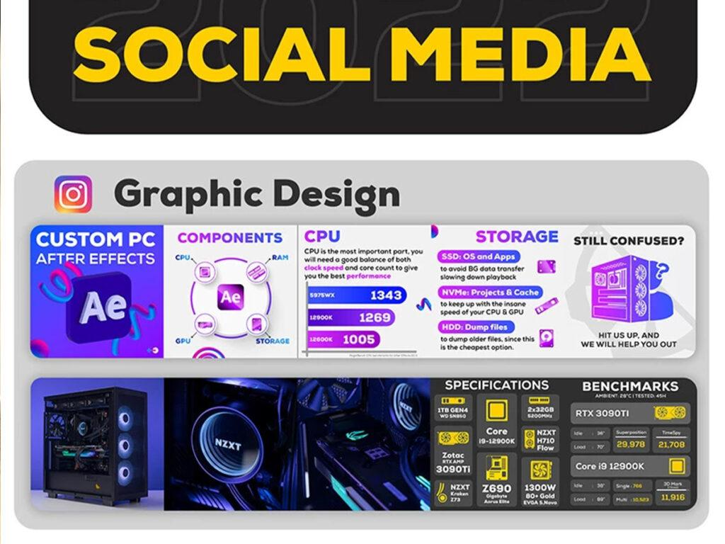Video Editing**



**4.3. Reviews By Clients**

**Karishma Narayanan - Marketing Manager, Emerson -** “Thank you very much for the great work shared and supersonic turnaround times!”

**Mohammed Ahmer - Managing Director, TheMVP -** “We had a 7x increase in Social Media sales along with more repeat orders – thanks to you guys!”

**Chapter 5**

**DATA INTERPRETATION & ANALYSIS**

Digital marketing is an excellent way of getting seen by people online. Companies are taking the help of digital marketing to reach out to the targeted customers in the most efficient way. This means there is big scope for digital marketing in India in the upcoming years. It is even estimated that by the end of 2025, more than 67% of Indians will actively use social media sites. Mobile phones have become a crucial way of interacting with potential customers for the success of digital marketing advertisements.

Today, digital marketing has emerged as an important way to build a strong online presence. Small businesses, startups, and even established brands use digital marketing services to be seen by more people. And plus if you want a job in digital marketing, you must know how to automate the process with the knowledge and skills to use CRM and SaaS companies.

The younger generation is driving up the statistics for video ads. According to Forbes, there is a clear societal shift where teenagers and young adults are moving away from social media platforms like Facebook and Twitter (which are now filled with political content) and towards visual-based platforms like Snapchat, Instagram, YouTube, or TikTok. Advertisers who intend to engage the younger generation of consumers, need to remember that the requirements for grabbing user attention will be completely different. For once, video content and human creativity are what gets the attention. Video advertising can give brands newfound leverage. Cisco estimates that video will account for 82% of internet traffic globally by 2022. Expert predictions also see the rise in popularity of user-generated content and AR and VR content.

The next decade is bound to see many technological advancements and a lot of them will be tied to video. Multiple platforms with social aspects invest in more video making and sharing options for the community and the advertising industry is following right behind. Companies who want to appeal to younger users should adjust their creative messaging to make it suitable for social media. The future of advertising depends largely on the younger audience and so far it seems that video ads are in high demand.

While spending on desktop advertising is facing a slight decline, mobile advertising keeps growing. And while this is not news to anyone from the technology industry, the continuous growth of mobile advertising means that in 2022 more brands will shift their budgets. Adoption of mobile devices has always been high for younger demographic groups, however, there has been a rapid growth in the percentage of older adults who now own a smartphone.

As of 2021, 96% of those aged 18 to 29 and 61% of adults over 65 own a smartphone. What’s more, while it’s still the smallest number out of all the age groups, the percentage of older users who use social media has grown four times in the past decade. In 2022, social media apps are most frequently used on mobile devices and customers prefer shopping via apps over the browser version of the shop website. They’re also 200% more likely to engage with the brand through mobile devices. What’s important to remember is that mobile advertising only works if it’s done well. Companies that run promotions and create engagement strategies for mobile devices need to remember one thing – optimization is key. Slow loading time, issues with image display, or bad user experience are likely to deter users from seeking that brand’s services again.

Here are a few roles Digital Marketing provides as of the current and future advertising trends and tactics -

**1. Become a Professional Blogger**

Many people choose to become full-time bloggers to have a work-life balance. But if you are choosing blogging as a full-time career, you must be dedicated and need to work hard to become successful in your niche.

Many skilled full-time bloggers generate affiliate marketing and advertising in a range of $100 to $1000 per month. In addition, top and successful bloggers are able to earn up to $10,000 per month.

**2. Earn with Affiliate Marketing and AdSense**

You can even start earning by starting a website, app, or blog in a specified niche. Selecting a niche that you are familiar with or have worked on will help you generate more traffic. After generating traffic, you can start making good income through AdSense and affiliate marketing. Many experts have even developed micro-niche websites that focus on the topics that generate the most traffic.

**3. Start Freelancing Services**

Freelancing services are seen as the future scope of digital marketing in India as it allows a person to work with multiple clients. What’s best? Well, freelancers can offer their services irrespective of their location. This thing helps freelancers to work with global clients without any hassle. You can find ideal clients for your work through popular platforms like freelancer.com and fiverr.com.

**4. Start Your Agency**

If you have resources and experience managing a business, you can start your agency. Once you start your full-time digital marketing agency, you can build better marketing strategies for your clients. Also, you would be able to implement the strategies in the best possible way.

**5. Become a YouTuber**

If you are passionate about a niche and have the talent for creating powerful videos, you should plan on becoming a YouTuber. You need to stay focused on creating quality content to reach the maximum number of audiences. Better quality videos will help you get more views and subscribers, which will increase the amount of money you make through YouTube monetization.

**6. Start a Dropshipping Business**

Lately, the dropshipping model has become quite popular as it allows an individual to sell products online without asking them to own a physical inventory. If you are willing to try dropshipping, you must create an eCommerce business website on Shopify. After that, you are required to select the products and connect with the manufacturers and online retailers. The products that you select for dropshipping are marked up. So, when you make a sale, the manufacturer directly sends the product to the customer. This way, you make a good profit.

**7. Future Scope of Online Careers for Professionals/Students**

You can unlock new online opportunities by learning digital marketing. What’s better? You can learn digital marketing along with your current job or course. A study has revealed that numerous digital marketers have become influencers in a selected niche by building their personal brands. Furthermore, students get a chance to work with multiple digital marketing agencies part-time.

**8. Scope as Trainer or Coach**

If you are interested in teaching, you can share your knowledge with others by becoming a better digital marketing trainer or coach. Having prior teaching experience can be helpful. There is a huge scope for digital marketing trainers in India. You need to have in-depth knowledge and a practical understanding of each topic to explain it in a better way. You can work on real-time projects before training to expand your knowledge. Remember that you can only become a trainer after you have gained a good amount of experience.

**9. Content Marketer**

A content marketer is another scope of digital marketing job in India. These professionals represent the entire digital marketing team and are responsible for creating high-quality content. Their main aim is to engage the audience with their content.

**10. Email Marketer**

You can also become an email marketer and promote products, services, or pages to generate leads. When you start your career as an email marker, your salary will be average, but it will increase as you get experience.

**11. Digital Marketing Manager**

Another interesting scope of digital marketing in India is the digital marketing manager. This role requires you to implement, plan, develop, and manage a company’s entire digital marketing strategy.

**12. SEO Specialist**

An SEO specialist can be seen as the future scope of digital marketing in India. As a specialist, you must optimise the website for search engines by suggesting, implementing, reviewing, and analysing the changes. Your job also requires you to implement keyword research strategies.

**13. Search Engine Marketer**

Professional search engine marketers must work dedicatedly so that the company gets correctly exposed to the right customers on the search engines. These professionals are responsible for promoting the website’s visibility through organic search rankings, paid search contextual advertising, and other methods.

**The Future Scope of Digital Marketing For Businesses**

Over the past few years, digital marketing has shown steady growth. Plenty of opportunities are coming in this domain, making it easy for digital marketers to find the right career path. Internet consumption has heavily increased since the COVID-19 pandemic. People have now started doing most of their tasks online and have started to understand the importance of digital marketing. It can be said that the future generation will readily accept the digital marketing culture and will get accustomed to getting everything done online. Almost all companies have made themselves digitally available to customers. And the ones that have not yet joined the digital marketing group will have to start now so they don’t get lost.

After seeing the number of opportunities and interests of people shifting towards digital marketing, it can be said that the future of this industry seems to be very promising.

Digital marketing has made it possible for small businesses and entrepreneurs to increase their ROI and roll out effective ad campaigns. In time, the effectiveness of digital marketing practices will reach new heights and allow companies to make the most out of AI, SEO, AR, and VR tactics.

**Chapter 6**

**FINDINGS SUGGESTIONS AND CONCLUSION**

**6.1. FINDINGS**

Throughout this study I have learnt a lot about Digital Marketing that I had not known. The statistics of all digital marketing strategies are major parts of the project that had an impact on me. The main things that I could gather and understand from this study are as follows -

1. It was observed in the study that Digital Marketing has been experiencing a steady growth, and an immense one since the year 2020 2. According to the study, Digital Marketing .

2. According to the study, Digital Marketing requires minimum or no investment, depending on the need, all one requires is a mobile phone or a computer.

3. Digital Marketing has certain tactics and softwares on which the marketing is based, it is highly important to know how to use them before getting started with it.

4. Almost all people spend a high time on their phones and about 60% of the population get influenced

5. has been playing a vital role in the cause.

**6.2. SUGGESTIONS**

1. The study suggests that start-ups perform very well under Digital Marketing.

2. This study proposes that people starting a business as a Digital Marketing agency should have full knowledge about the various aspects of it.

3. The study advises to keep a keen observation on the process and growth in order to become more influential among various generations.

4. Be it any age, any gender or any profession everybody is largely dependent on online marketing and are highly affected by what they see online or on social media.

**6.3. CONCLUSION**

Through this study we can conclude that advertising in the future will wholly be dependent through online means, albeit not totally on Digital Marketing. Advertising these days has been 85% online because no matter what age, gender or profession, everyone has a smartphone and 80% of the population has screen time over 6 hours per day. Digital Marketing can be performed by various people at different positions and roles, but talking particularly about as a business or startup, it has the highest scope, as there is no investment required here, it is easy to go through with and with experience and knowledge about it’s tactics and process a person can start a business and attract a lot of customers with his creativity and strategies within no time.

**REFERENCES**

[How Digital Marketing Can Take Your Startup To A Higher Level](https://www.forbes.com/sites/forbesagencycouncil/2018/08/10/how-digital-marketing-can-take-your-startup-to-a-higher-level/?sh=53c71acd6789)

[Digital marketing is more important now than ever. My recommendations on the challenges and opportunities for growth](https://www.smartinsights.com/digital-marketing-strategy/digital-strategy-development/10-reasons-for-digital-marketing-strategy/)

[Digital Marketing Overview: Types, Challenges, and Required Skills](https://www.investopedia.com/terms/d/digital-marketing.asp)

[Marketers Don’t Talk About Data Privacy, But They Should](https://www.forbes.com/sites/forbesagencycouncil/2022/12/08/marketers-dont-talk-about-data-privacy-but-they-should/?sh=2d9df1ad4815)

[What Is Digital Marketing? Types, Skills, and Careers](https://www.coursera.org/articles/digital-marketing)

[What Is Digital Marketing?](https://neilpatel.com/what-is-digital-marketing/)

[What Is Digital Marketing? Definition + 11 Strategies for 2023](https://www.shopify.com/blog/digital-marketing)

[What is Digital Marketing?Learn the basics of digital marketing and how it can help your company reach its goals.](https://www.salesforce.com/resources/articles/digital-marketing/)

[What is Digital Marketing and Its benefits?](https://engaiodigital.com/digital-marketing/)

[What Is Digital Marketing: A Beginner’s Guide](https://www.feedough.com/digital-marketing-guide/)

**WEBLIOGRAPHY/BIBLIOGRAPHY**

<https://www.simplilearn.com/history-and-evolution-of-digital-marketing-article#what_is_digital_marketing>

<https://www.forbes.com/sites/forbesagencycouncil/2018/08/10/how-digital-marketing-can-take-your-startup-to-a-higher-level/?sh=6afd47666789>

<https://www.researchgate.net/publication/333709419_Digital_Marketing_A_Review>

<https://www.ijsr.net/archive/v6i2/ART2017664.pdf>

<https://www.mygreatlearning.com/blog/introduction-to-digital-marketing/>

<https://www.tutorialspoint.com/pinterest_marketing/digital_marketing_introduction.htm>

<https://www.simplilearn.com/the-scope-of-digital-marketing-article#the_scope_of_digital_marketing_social_media_and_beyond>

<https://digitalscholar.in/scope-of-digital-marketing/>

<https://digitalcatalyst.in/blog/what-are-the-main-advantages-and-disadvantages-of-digital-marketing/>

<https://newprogrammatic.com/blog/future-of-advertising/#The_future_of_digital_ads_lies_in_user_willingness_to_opt-in>

[google.com](http://google.com/)

<https://picturethis.co.in/>